Library Management System
University of Mindanao Tagum College - Visayan Campus


A PROJECT PROPOSAL FOR PROFESSIONAL TRACK FOR IT13
PROFESSIONAL TRACK FOR IT4
SUBMITTED TO
KATE STEFUNNY T. BRUNO
SUBMITTED BY
ODRUÑA, TWINKLE PRIL
SIOJO, ART LAURENCE
TALAMILLO, TRISHA

January 2026

Table of Contents
Page
CHAPTER 1
INTRODUCTION
Project Context 1
Statement of the Problem 3
Objectives
General Objective 4
Specific Objectives 4
Scope and Limitations 5

CHAPTER 2
SYSTEMS DESIGN
Prototype 6
System Diagrams:
UML Class Diagram 16
Use Case Diagram 17
ERD (Entity Relationship Diagram) 18
CHAPTER 3
SYSTEM REQUIREMENTS
Functional Requirements 19
Non-Functional Requirements 20
References 21

CHAPTER 1
INTRODUCTION

Project Context
Managing library resources is far more than a routine administrative task for schools and public institutions—it forms the backbone of how knowledge is shared and information flows within communities. Yet many libraries continue to rely on outdated or fragmented systems. As a result, simple processes such as tracking borrowed books, determining borrowing eligibility, or calculating overdue fines often become unnecessarily complicated and time-consuming.
The proposed Library Management System addresses these challenges directly. Developed as a Windows Desktop Application using C# .NET Framework and WinForms, it consolidates core functions into a single platform. Cataloging, circulation tracking, member management, and report generation are all integrated, creating a streamlined system that reduces inefficiencies (Bhati et al., 2024).
Global research underscores the importance of automation in modern library operations. Effective systems are built on strong software architecture and fundamental Object-Oriented Programming concepts—encapsulation, inheritance, polymorphism, and abstraction—which ensure both data security and scalability. Adhering to established design principles such as SOLID not only minimizes errors but also enhances maintainability and prepares the system for future growth (Ikwuanusi et al., 2024).
In the local context, libraries are increasingly adopting digital solutions capable of managing diverse resources, including journals, dissertations, and ebooks. Automated systems provide immediate visibility into the status of materials— whether available, checked out, reserved, lost, or damaged. This eliminates the need for staff to sift through paperwork or manually track users, enabling them to provide accurate information instantly (Mir, 2024).
The system also accounts for the varied needs of different user groups. Students, faculty, alumni, and guests each have distinct borrowing privileges, and the software enforces these rules automatically. From borrowing limits to renewal policies and fine calculations, the system ensures consistency and fairness across all categories of users.
Despite advances in automation, some institutions remain reliant on manual checks and error-prone fine calculations. The new system closes these gaps by fully automating borrowing validation, member tracking, and the generation of precise financial and statistical reports. This eliminates guesswork, reduces wasted time, and ensures reliable data management (Automation of Library Services, 2024).

Statement of the Problem
The University of Mindanao Tagum College continues to rely on manual or semiautomated processes in library management. These outdated methods result in slow operations, frequent errors, and limited access to accurate information, causing frustration among staff and students. The specific problems identified are:
- Inefficient Circulation Tracking and Data Integrity – Manual recording of borrowings and returns is prone to human error and lacks real-time updates on book availability.
- Lack of Consistent Rule Validation – Borrowing limits, member eligibility (Student, Guest, Professor, Alumni), and book availability are difficult to enforce without automated checks.
- Inaccurate and Time-Consuming Fine Management – Manual calculation of overdue penalties based on varying daily rates and member types is complex and often inaccurate.
- Poor Inventory Visibility – Large volumes of resources and multiple copies of titles make it difficult to track physical locations and copy status accurately.
- Inadequate Reporting and Analytics – The absence of a centralized database prevents timely generation of usage statistics, popular titles, and peak borrowing times.
- Limited Search Capabilities – Retrieving specific information by title, author, or ISBN is inefficient without advanced filtering, Boolean operators, and fulltext search tools.

General Objectives
To design and develop a comprehensive Windows Desktop Application using C# .NET WinForms that effectively manages and automates the core functions of library operations, including cataloging, circulation, member management (Students, Guests, Professors, Alumni), and reporting for the UMTC Library.

Specific Objectives
- Develop a secure, role-based User Management Module.
- Create a Cataloging Module for multiple resource types with status tracking.
- Implement a Circulation Module for book checkout/return with validation checks.
- Develop a Fine & Penalty Management Module for overdue, lost, or damaged items.
- Create a Search & Discovery Interface with advanced filtering options.
- Implement a clear class structure using OOP and SOLID principles.
- Design a normalized database schema (3NF) using SQL Server/MySQL.

Scope and Limitations
The project covers the development of a C# .NET WinForms Desktop Application that addresses the core requirements of library operation. This includes User Management (role-based access for Librarian/Admin, Library Staff, and Members) , Member Management (registration, status tracking, and setting different privileges based on member type) , Cataloging (management of books and resource copies, including location and status tracking) , Circulation (optimized borrowing, returning, and renewal processes with strict rule validation and due date calculation) , and Reporting (generation of circulation, member, and collection reports, and a main Dashboard displaying key metrics) .
The system is subject to the following limitations: it is restricted to a Windows Desktop environment using WinForms; it is not a web or mobile application. The database is limited to using either SQL Server or MySQL. The Functional Scope will not include external integration with payment gateways for online transactions; payment processing is limited to recording cash or online payments. While the Circulation Interface is designed for barcode scanner support, the scope of the project focuses on the system logic and UI; procurement or physical integration of the actual hardware is outside the scope. Finally, for E-Books, the system handles the record and provides a download link; it does not include the actual file hosting or complex Digital Rights Management (DRM).
CHAPTER 2
SYSTEMS DESIGN

Prototype
In this login prototype, the Library Management System presents a secure, rolebased authentication interface developed using C# .NET Framework WinForms. The system allows librarians/administrators, library staff, and library members to log in using unique credentials. Upon successful authentication, users are redirected to interfaces corresponding to their roles, ensuring controlled access to system features. Librarians and administrators are granted full access to system configuration, catalog management, circulation, and reporting modules, while library staff can process borrowing and returns, manage members, and update inventory. Library Members (Students, Guests, Professors, Alumni) can search the catalog, view borrowed books, reservations, and fines. This prototype demonstrates proper user authentication, authorization, and access control as the foundation for secure library system operations.
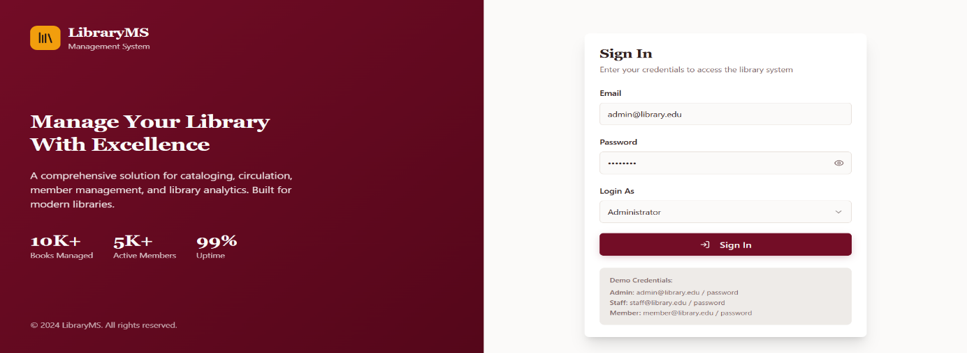

Figure 2.1 Web Login Page for Librarian/Admin Account
illustrates the Library Management System login page for the Librarian/Admin account. It shows the interface where librarians and system administrators enter their registered email address and password to securely access the system with full administrative privileges
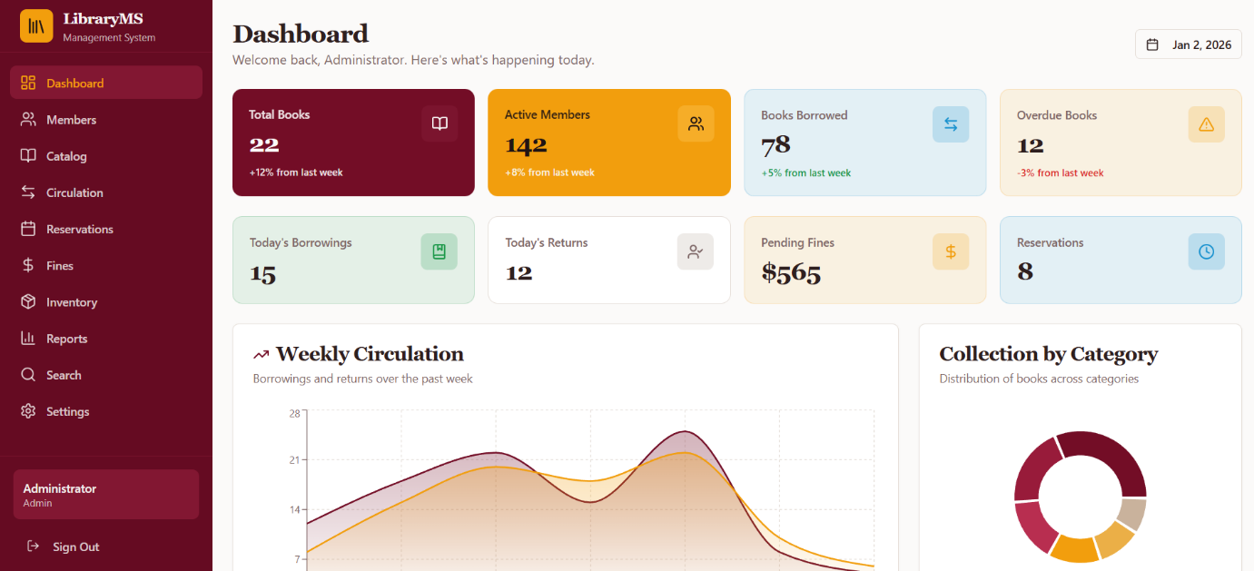

Figure 2.2 Library Member account Dashboard
illustrates the Library Management System login page for library members. It presents the interface where registered members—including Students, Guests, Professors, and Alumni—enter their credentials to access limited system features, such as catalog search, book reservations, viewing borrowed books, and monitoring fines and penalties.
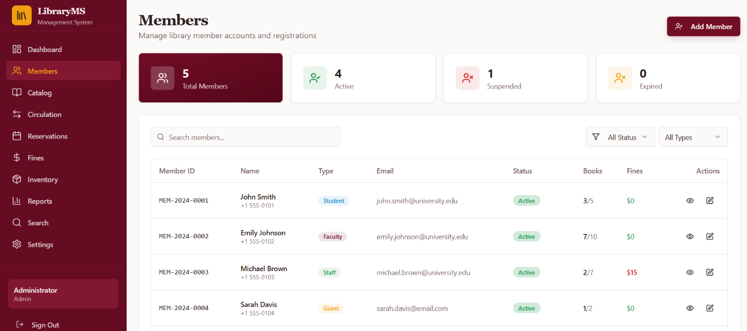

Figure 2.3 Members management interface of the Library Management System
This displays an overview of registered library members, including total membership statistics, account status (active, suspended, expired), and individual member details such as member ID, role type, contact information, borrowing activity, outstanding fines, and available administrative actions.
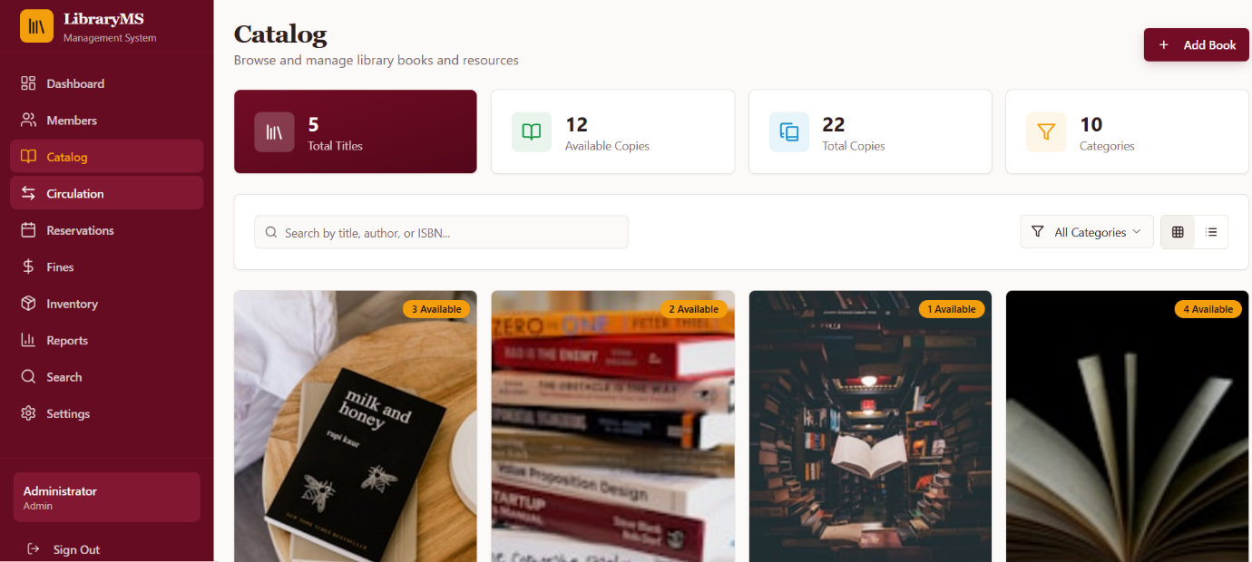

Figure 2.3 LibraryMS catalog interface displaying an overview of library resources.
The dashboard presents key metrics including total titles, available copies, total copies, and categories, along with search and filtering functions for efficient browsing and management of books and resources.
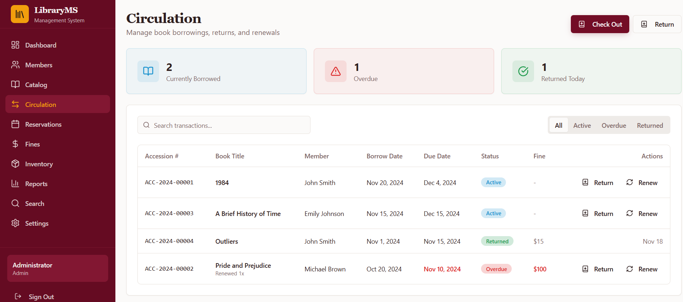

Figure 2.4 Circulation Report interface

illustrates the Circulation Report interface of the Library Management System. It shows summarized data on daily borrowing and returns, overdue books, and circulation trends within the library.

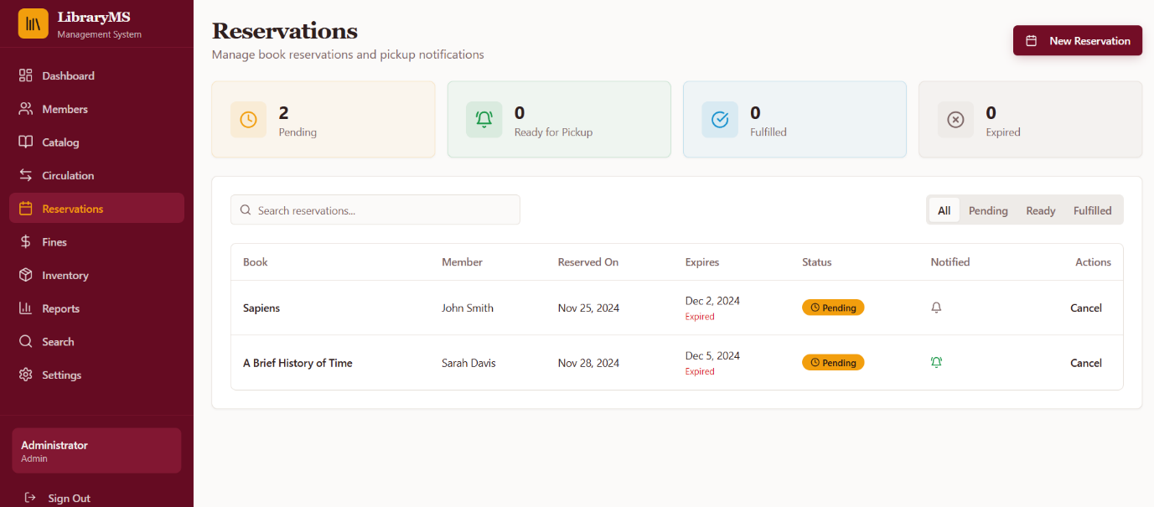

Figure 2.5 LibraryMS reservations interface for managing book reservations.
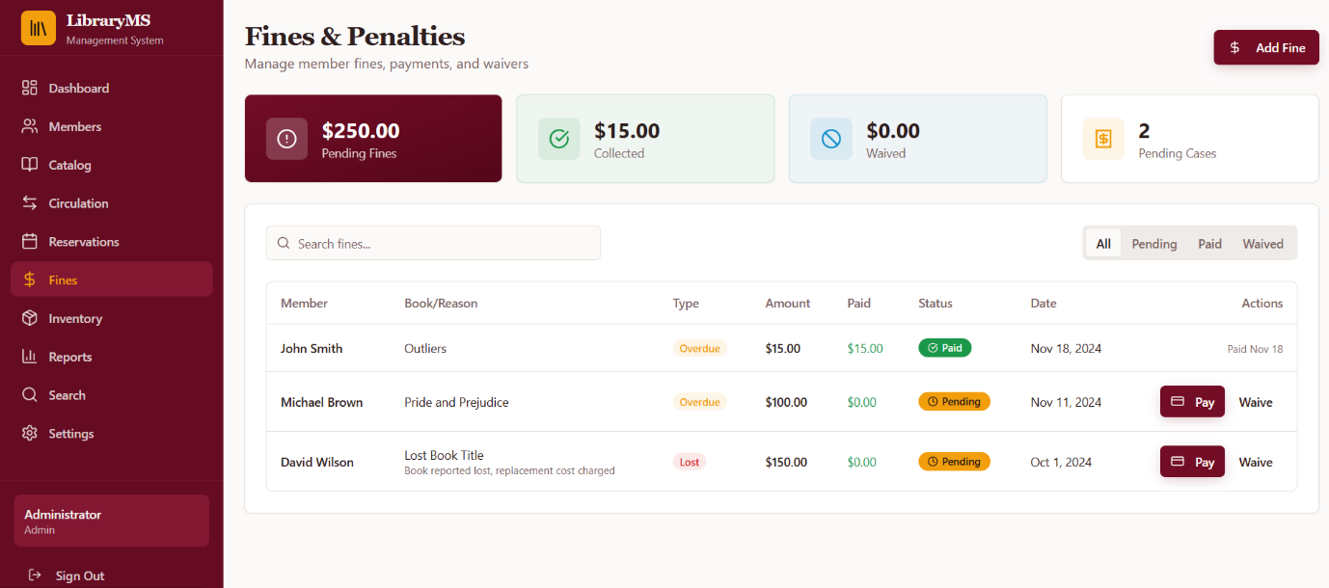
The screen shows reservation status summaries (pending, ready for pickup, fulfilled, and expired), detailed reservation records by book and member, expiration dates, notification indicators, and administrative actions for effective reservation tracking and control.

Figure 2.8 Overdue Fines Management Interface
illustrates the Overdue Fines Management interface. The system automatically computes fines based on the number of overdue days, member type (Student, Guest, Professor, Alumni), and configured daily fine rates.

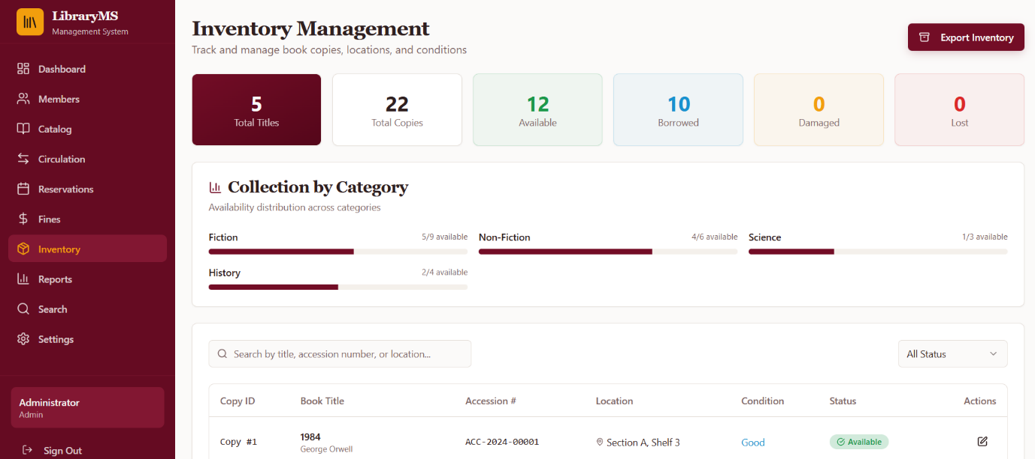

Figure 2.6 Inventory Report module

The figure illustrates real-time tracking of library holdings, including total titles and copies, availability status (available, borrowed, damaged, and lost), collection distribution by category, and detailed copy-level information such as accession numbers, locations, conditions, and administrative actions.
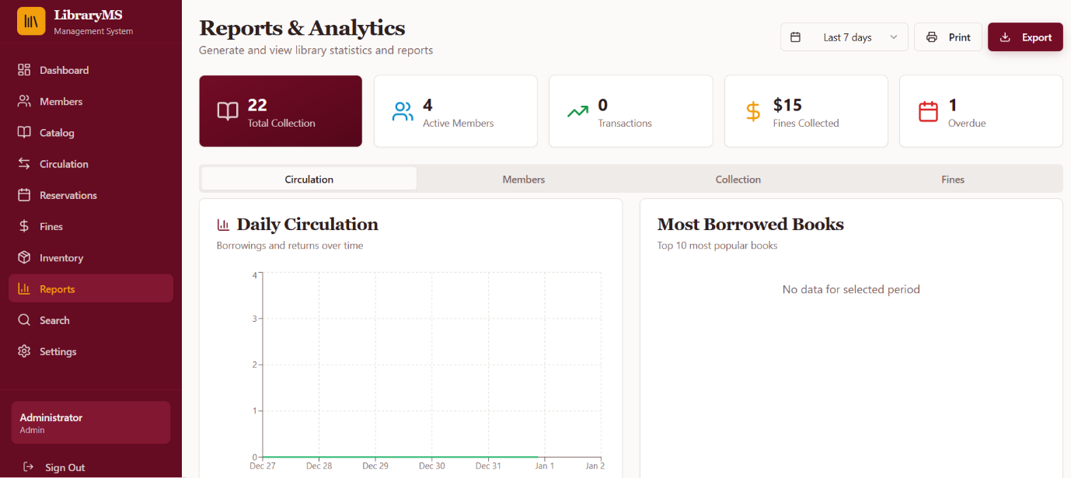

Figure 2.9 Reports and Analytics Dashboard
This interface presents key library performance indicators, including total collection count, active members, transaction activity, fines collected, and overdue items. It also features visual analytics such as daily circulation trends and a summary of most borrowed books, supporting data-driven decision-making for library administrators.
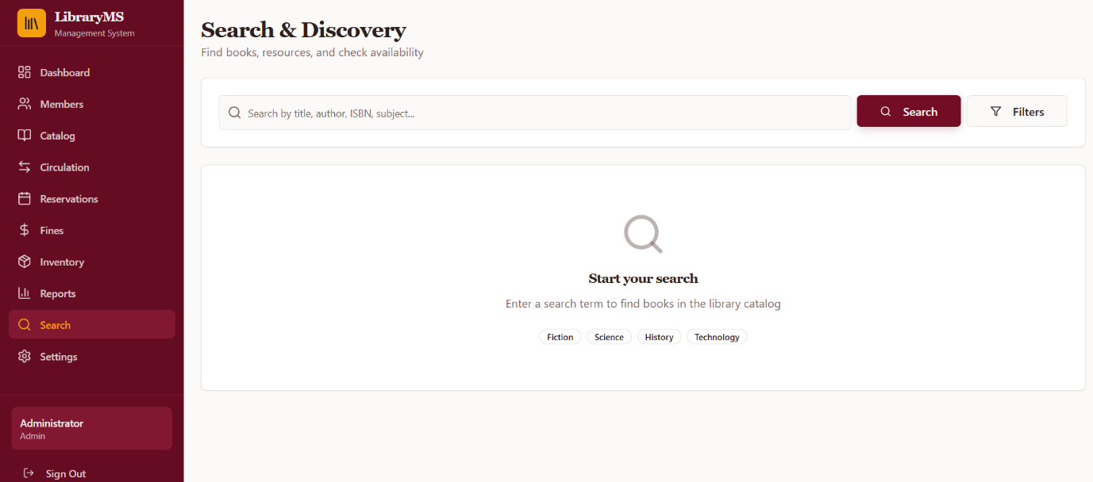

Figure 2.10 Search and Discovery Interface of the Library Management System.
This screen shows the book search and discovery module, allowing users to locate library resources by title, author, ISBN, or subject. It includes search filters and category suggestions to enhance usability and improve access to library collections.
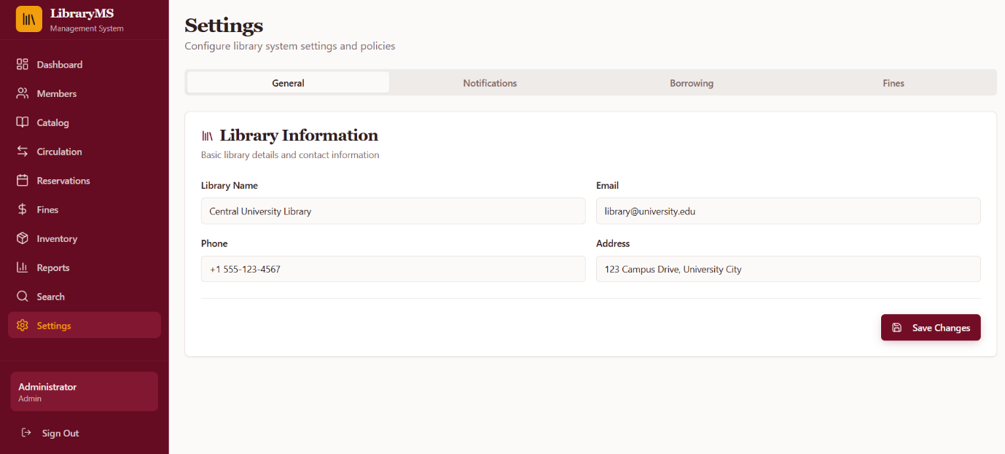

Figure 2.12 Settings module of the Library Management System (LibraryMS).
This interface allows administrators to configure core library information and system policies, including library contact details, notification preferences, borrowing rules, and fine settings, supporting centralized and efficient system managementUML Class Diagram
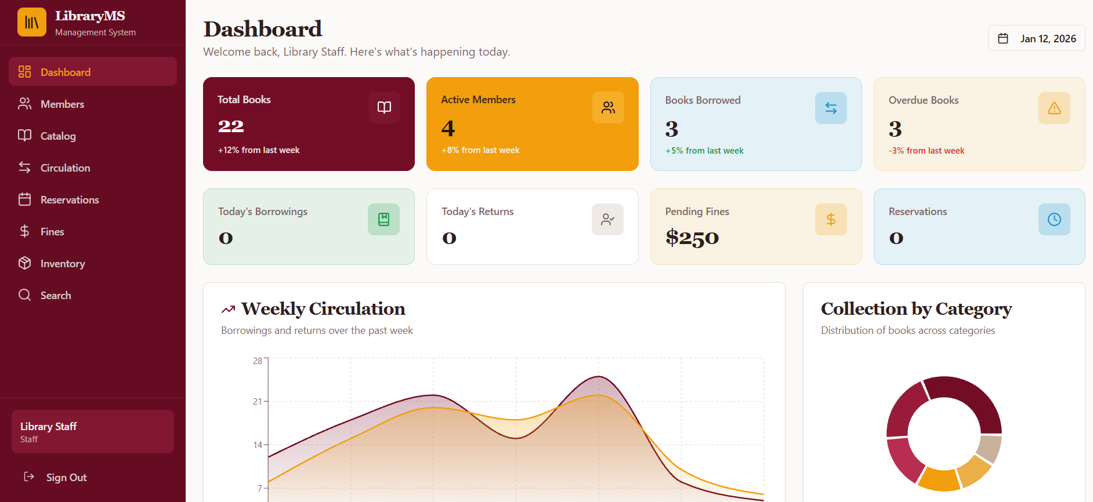

Figure 2.11 LibraryMS Dashboard Interface
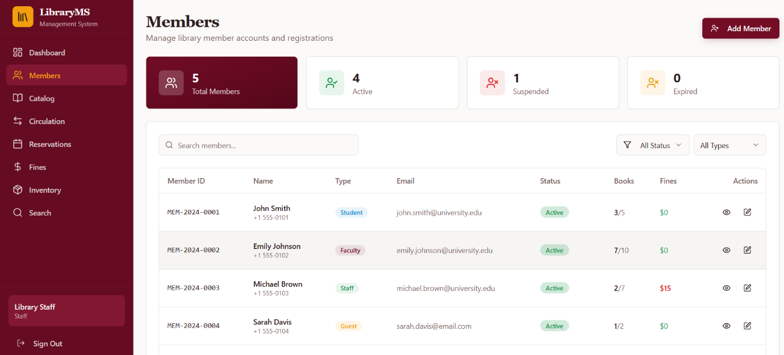
This figure presents the main dashboard LMS displaying key operational metrics such as total books, active members, borrowed and overdue books, pending fines, and reservations. It also includes visual analytics for weekly circulation trends and book distribution by category, providing library staff with an overview of daily and weekly library activities.

Figure 2.13 LibraryMS Members Management Module.
This figure illustrates the Members module of the Library Management System, which enables library staff to manage registered users. The interface shows member statistics by status, search and filtering options, and a detailed table containing member information such as ID, type, contact details, borrowing limits, fines, and available actions for account management.
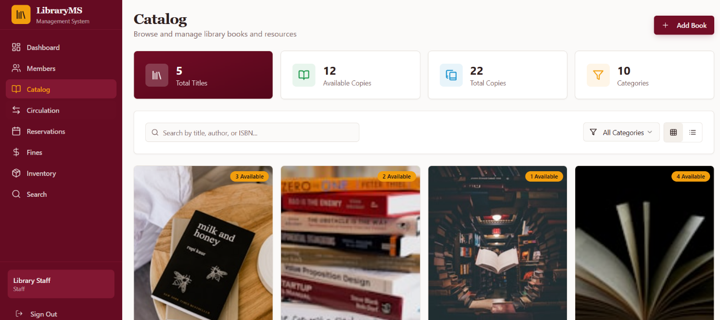

Figure 2.14 The LibraryMS catalog module presents the collection of library books and resources. It displays the total titles, available and total copies, and book categories. The interface also allows users to search and filter books based on specific criteria.
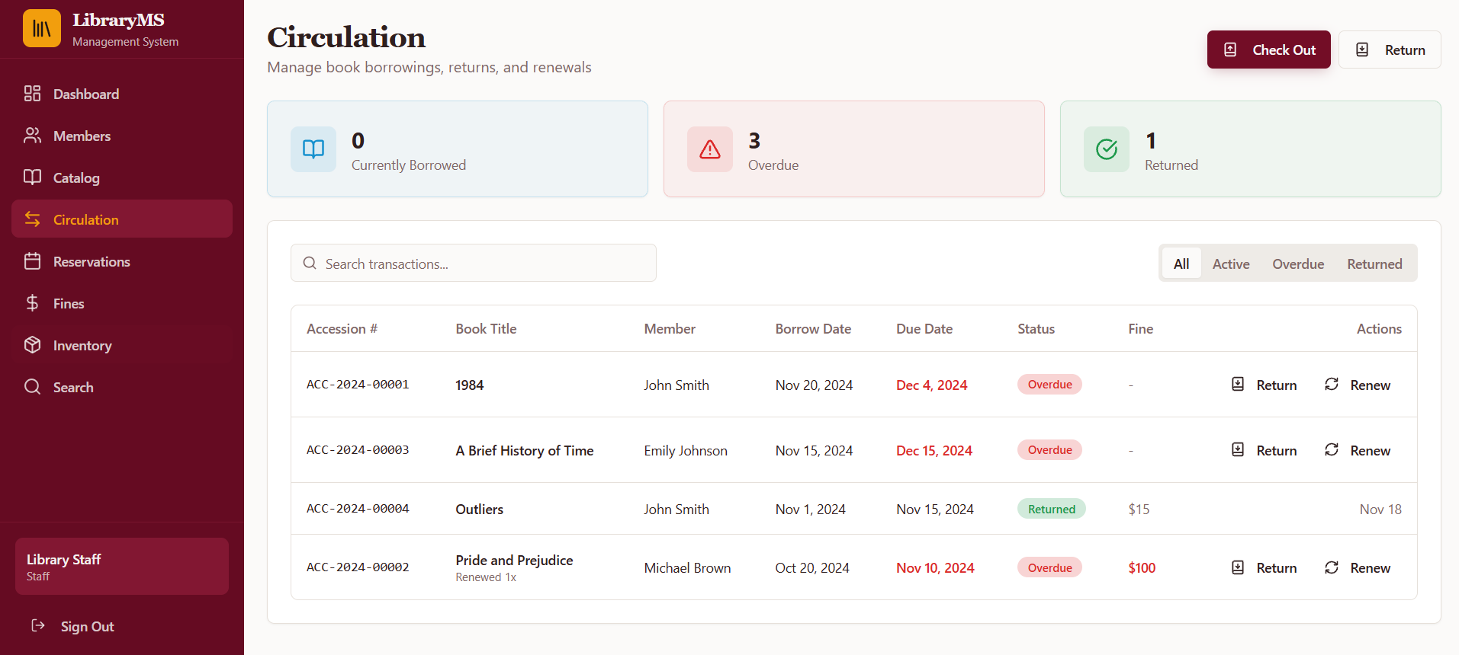

Figure 2.15 Circulation Module Interface of the Library Management System.
This figure illustrates the circulation module used to manage book borrowing, returns, and renewals. It displays real-time summaries of currently borrowed, overdue, and returned books. The transaction table provides detailed records including accession number, borrower, due dates, fines, and available actions.
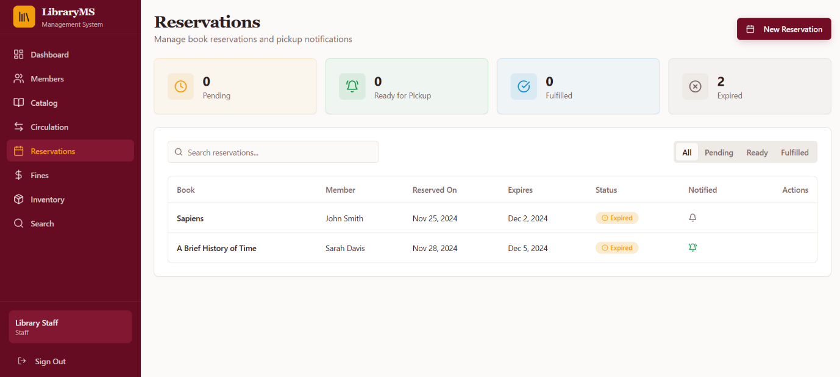

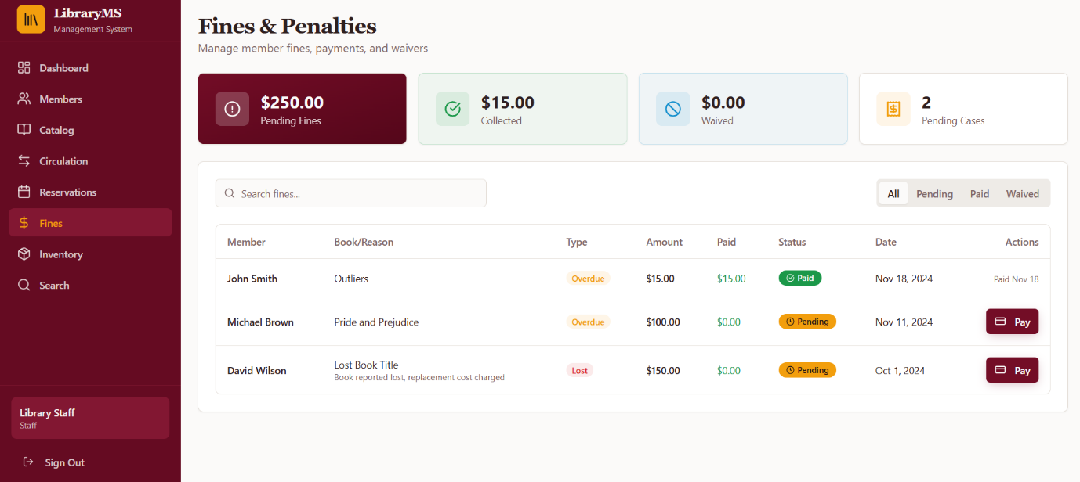
Figure 2.16 Reservations Module Interface of the Library Management System.
This figure presents the reservations module for managing book reservations and pickup notifications. It summarizes reservation statuses such as pending, ready for pickup, fulfilled, and expired. The table lists reserved books with member details, reservation dates, expiration dates, and notification status.

Figure 3. Fines and Penalties Module Interface of the Library Management System.
This figure shows the fines and penalties module used to monitor and process member fines. It highlights total pending fines, collected amounts, waived fines, and pending cases. Detailed records include the reason for fines, amount due, payment status, and available payment actions.
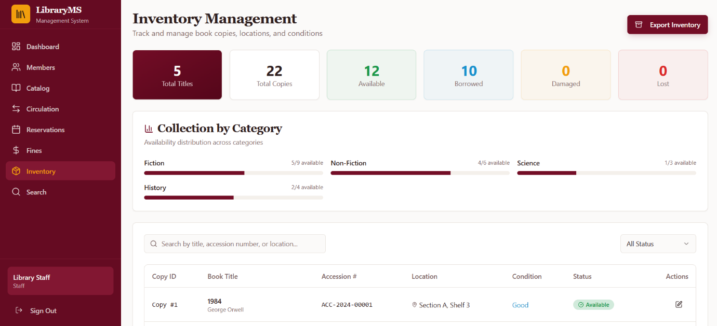

Figure 1. Inventory Management Module of the Library Management System.
This figure presents the Inventory Management interface used to track book titles, copies, availability, and condition status. Summary cards provide an overview of total titles, copies, available, borrowed, damaged, and lost items. The module also displays collection distribution by category and a detailed table of individual book copies.
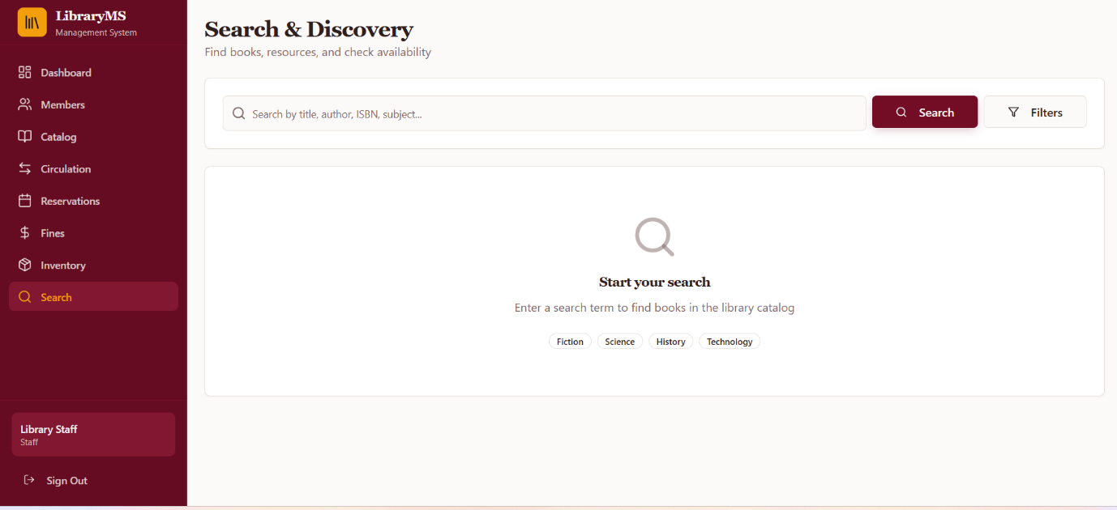

Figure 2. Search and Discovery Module of the Library Management System.
This figure shows the Search and Discovery interface designed to help users find books and check their availability. It includes a unified search bar supporting queries by title, author, ISBN, or subject, along with filtering options. Category shortcuts are provided to guide users in quickly initiating searches within the library catalog.
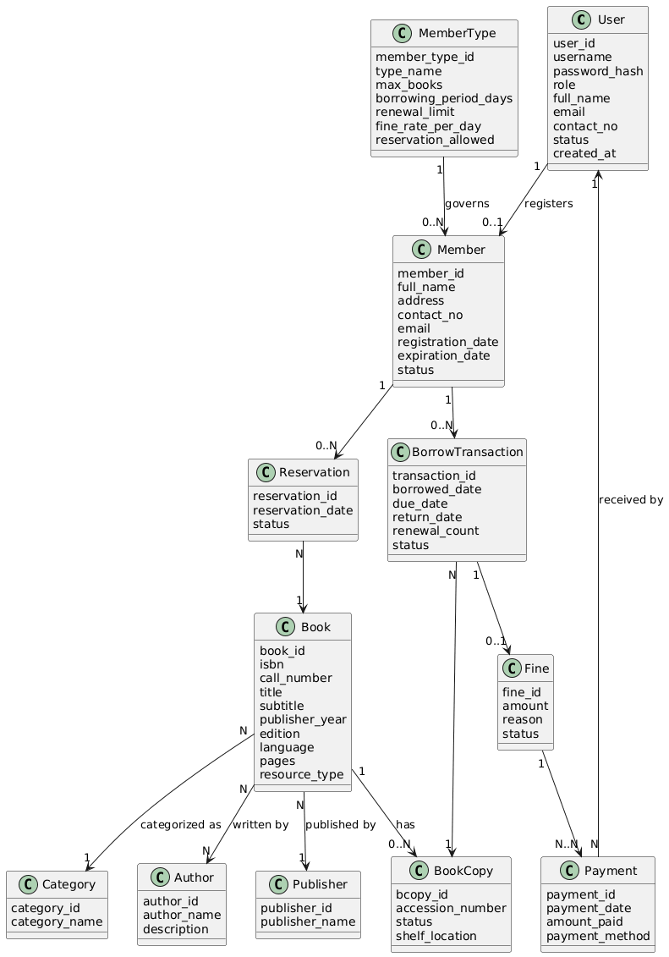

Figure 2.6 UML Class Diagram

Figure 2.6 The UML Class Diagram shows the object-oriented structure of the proposed Library Management System. It defines the core classes such as User, Member, MemberType, Book, BookCopy, Author, Publisher, Category, BorrowTransaction, Reservation, Fine, and Payment. The diagram illustrates the relationships among classes, including associations and multiplicities, which represent real-world library operations such as book borrowing, reservation, fine management, and payment processing. This diagram demonstrates the application of object-oriented design principles, including encapsulation and abstraction, and serves as a blueprint for the system’s implementation.

USE CASE DIAGRAM
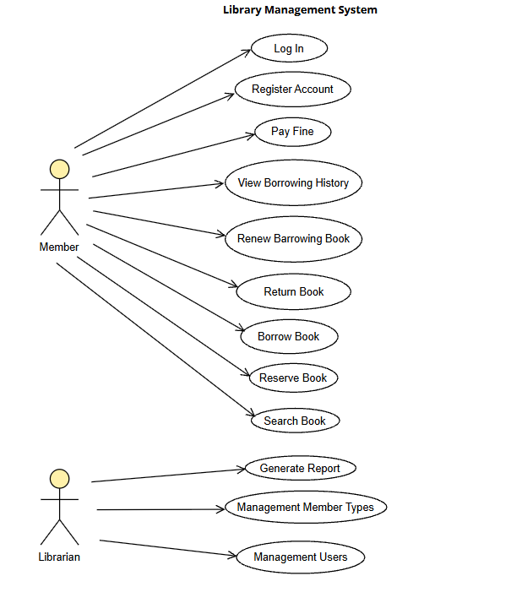

Figure 2.7 Use Case Diagram
Figure 2.7 The Use Case Diagram illustrates the functional requirements of the Library Management System from the user’s perspective. It identifies the primary actors—Member, Librarian, and Administrator—and their interactions with the system, including searching books, reserving and borrowing materials, managing book records, handling returns, calculating fines, and generating reports. The diagram defines the system boundaries and provides a clear overview of how different users interact with the system to achieve specific goals.

ERD (Entity Relationship Diagram)
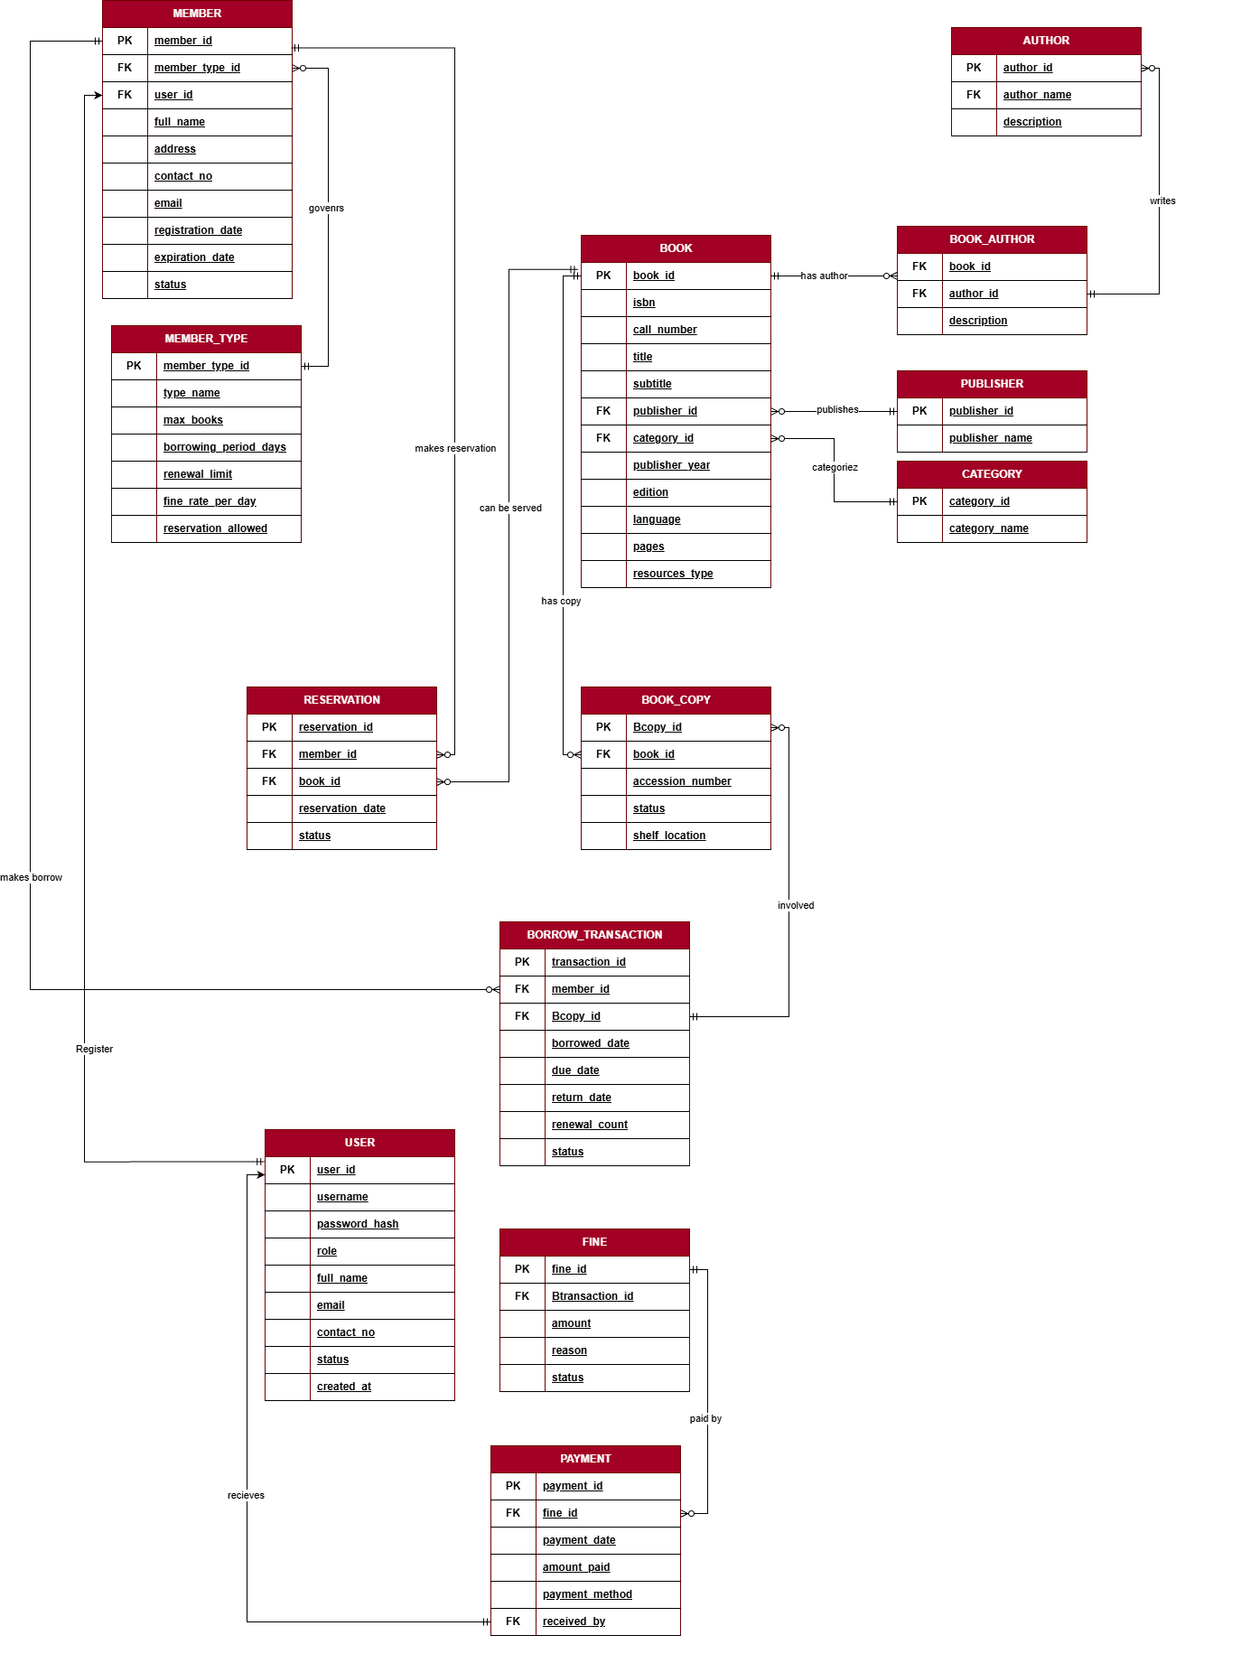

Figure 2.8 Entity–Relationship Diagram of the Library Management System.
The diagram illustrates the complete database schema of the proposed library management system, showing core entities such as Member, Book, Book Copy, Author, Publisher, Category, Reservation, Borrow Transaction, Fine, Payment, User, and Member Type. It defines primary and foreign keys, attributes, and the relationships with their cardinalities, representing processes including book cataloging, borrowing, reservation, fine management, and payment tracking within the system.
CHAPTER 3
SYSTEM REQUIREMENTS

Functional Requirements
- Librarians/Admin shall log in to the system using secure credentials.
- Library Staff shall manage book checkouts, returns, and renewals.
- Library Staff shall register new library members (Students, Faculty, Staff, Guests) and update member information.
- Members (Students, Faculty, Staff, Guests) shall search the catalog, reserve books, view borrowed items, and monitor fines.
- The system shall automatically calculate fines for overdue books based on member type and borrowing policies.
- Librarians/Admin and Staff shall manage book records, including adding, updating, and removing books and book copies.
- The system shall update book and copy status in real time (Available, Borrowed, Reserved, Lost, Damaged).
- The system shall allow members to reserve unavailable books and track reservation status.
- Librarians/Admin and Staff shall generate reports related to circulation, members, inventory, fines, and payments.
- The system shall provide a dashboard displaying key metrics such as total members, available books, borrowed items, overdue items, and pending reservations.
- The system shall allow exporting reports in CSV formats.
- The system shall maintain borrowing history and transaction records for auditing and reference purposes.

Non-Functional Requirements
- Performance: The system shall process transactions (checkout, return, renewal) within 3 seconds under normal operating conditions.
- Usability: The system shall provide an intuitive and user-friendly interface optimized for Librarians, Staff, and Members.
- Security: The system shall enforce authentication using encrypted credentials and protect sensitive user and financial data.
- Reliability & Availability: The system shall ensure high availability and continuous operation during library working hours.
- Compatibility: The system shall operate on Windows-based environments and support major versions of SQL Server or MySQL without requiring additional plugins.
- Auditability: The system shall log critical user actions, including book transactions, fine payments, and member account updates.
- Scalability: The system shall support growth in the number of users, members, and library resources without performance degradation.
- Data Integrity: The system shall ensure accuracy and consistency of data across all modules and exported reports.
- Export Accuracy: Exported files to CSV shall preserve data integrity and formatting.

References
Bhati, P., Verma, S., & Singh, R. (2024). Design and implementation of automated library management systems. International Journal of Library and Information Science, 16(1), 12–22. https://doi.org/10.5897/IJLIS2024.0987

Ikwuanusi, I., Okorie, N., & Adebayo, T. (2024). Applying object-oriented programming and SOLID principles in enterprise software systems. Journal of Software Engineering and Applications, 17(2), 45–58. https://doi.org/10.4236/jsea.2024.172004

Mir, S. A. (2024). Digital transformation of academic libraries: Challenges and opportunities. Library Philosophy and Practice, 2024, 1–14. https://digitalcommons.unl.edu/libphilprac/2024

Automation of library services. (2024). Library automation and digital resource management. https://www.libraryautomation.org

Pressman, R. S., & Maxim, B. R. (2020). Software engineering: A practitioner’s approach (9th ed.). McGraw-Hill Education.

Sommerville, I. (2020). Software engineering (10th ed.). Pearson Education.
Gamma, E., Helm, R., Johnson, R., & Vlissides, J. (2019). Design patterns: Elements of reusable object-oriented software. Addison-Wesley.

Microsoft. (2023). Windows Forms .NET documentation. https://learn.microsoft.com/en-us/dotnet/desktop/winforms

Silberschatz, A., Korth, H. F., & Sudarshan, S. (2020). Database system concepts (7th ed.). McGraw-Hill Education.

Breeding, M. (2021). Library systems report: Automation, data, and innovation. American Libraries, 52(5), 24–31.

